Module 1:

Overview of Microsoft Project 2010

Contents

Module Overview 1

Lesson 1: Success Factors of Project Management 2

What is a Project? 3

Project Management Tools (Why use Project 2010) 4

Formulate a Strategy 6

Success Checklist 7

Lesson 2: Exploring the ribbon 9

Task Tab 10

Resource Tab 11

Project Tab 12

View Tab 13

Format Tab 14

Backstage Tab 15

Lesson 3: Exploring the Project Database (.MPP file) 17

Project Data 18

Task Data 19

Resource Data 20

Assignment Data 21

Custom Fields 22

Lesson 4: Exploring Database Views 23

What is a Database View? 24

Task Views 25

Resource Views 29

More Views 32

Practice: Title of Practice 34

Summary 35

1

.

# Module Overview



Microsoft Project (Project 2010) is a very robust project scheduling and schedule management software. It is designed to create, plan and manage any type of project you would want to perform.

Project 2010 is a product that functions best when the “rules” are followed. This course is designed to teach the user the best practices of creating and managing projects using Microsoft Project Standard 2010 and Microsoft Project Professional 2010. Differences will be noted when necessary during this course.

In this lesson the topics to be addressed are:

1. Project Management overview
2. Success factors for your project schedule
3. Overview of Project 2010 ribbon or the Fluent Interface
4. Exploring the Project 2010 database (.mpp file)
5. Exploring the Project 2010 views and tables

# Lesson 1: Success Factors of Project Management



If you were going to build a house would you buy a piece of land, hire some contractors and tell them to build you a house? If that was your approach to building a house, what kind of house would you have built? Would it be the house you envisioned?

Another approach would be to pre-plan and design the type of house you would like and then buy the land and plan out how it would be built. You would define the work of the project and hire the contractors as needed for the work they will be performing. You would hire the right type of contractors for the job and you would be able to estimate the cost and timeline of the work.

Project 2010 is a very powerful scheduling tool. To gain the most benefit from the software, pre-planning your schedules will allow you to set goals for the output of your schedules and deliver better results.

In this lesson, Project Management and Project Schedule success factors will be discussed. Topics will include:

* What is a Project?
* Why use Project 2010?
* Formulate your individual project strategy
* Check list to achieve your success factors

## What is a Project?



A “Project” is a temporary undertaking that results in the production of a product, process or event. Projects differ from on-going work or business operations in that a project has a beginning and an ending. Usually, unique talents are needed in the performance of a project and when the project has concluded, these unique talents are released from the project.

Everyone plans and executes projects at different levels of detail. Whether projects are planning a trip, building a house or developing a new software module, all projects have the following traits:

1. A project concept is researched and a decision is made to carry out the project. Requirements as to the content of the project are described, and success goals for the project are determined.
2. Detail planning is performed to fully understand the nuances of the work required of the project and what it will take to accomplish the project. Other considerations are the amount of resources (workers) it will take to accomplish the project work, cost, risk, quality of the product being developed and timeline for the project.
3. The actual performance of the project with controls to bring the project to a successful conclusion.
4. Looking back at the project and learning from successes and errors to manage projects more successfully in the future.

There are many project management methodologies available and organizations will decide which methodology will best fit the needs of the organization.

## Project Management Tools (Why use Project 2010)



<Rolly: we should have a slide that shows the MSP/MSPS system for 2010. I want to show that MSP is part of the big picture. Got one???>

Project 2010 was designed to help the Project Manager schedule the work of a project and monitor the progress of the project. Some of the high level capabilities of Project 2010 are:

1. The ability to plan and manage a project using Work Breakdown Structure (outline) format
2. Work, duration and cost planning, forecasting and tracking
3. Flexible reporting capabilities and customization
4. Ability to interface with Project Server and Project Portfolio Servers to allow for integration of projects and resource management within an organization (Professional version only)
5. Project 2010 allows for both manual and automatic project scheduling
6. Resource management – planning and forecasting
7. Budget forecasting and tracking
8. Baseline and variance reporting
9. Schedule predictability and what-if scenarios
10. Dynamic schedule management

Project management software has a flow which reflects the project management process:

1. Projects are defined and the decision is made to perform the project
2. More indept planning is conducted to elaborate the tasks, resources and work required to complete the project
3. Projects will start to be performed
4. Tracking information of how the working is getting accomplished is feed back to the project manager and updated into the schedule
5. Stakeholders request changes to the product of the project
6. Reports are produced to reflect project status and schedule
7. Steps 4-6 are repeated until the project is completed
8. When the project is completed a transition will be made to incorporate the product of the project into the businss process.
9. Reflection is made as to how the project was performed looking for process improvement.

Rolly – I would try to make this diagram look better if you can.

Project 2010 was developed in two versions of project management software:

1. Project 2010 Standard is a desktop application and is considered a stand alone schedule management tool. There are capabilities for managing individual projects as well as management of multiple projects with a shared resource pool.
2. Project 2010 Professional has all of the features of Project 2010 Standard and has the ability to allow publishing of projects to a server environment. This allows for collaboration, communication and resource sharing across projects. A web application is available for on-line project planning, resource updates, and inquiries.

## Formulate a Strategy



Before a project schedule is created, define what information you are hoping your schedule will return for the work and time you devote to the using the schedule. .

Set your goals for the project schedule:

1. Define the type of information your project schedule should return?
   1. When performing home remodeling you might be interested in when to schedule the contractors.
   2. When developing a software module you might be interested in estimating work hours of resources and costing.
   3. When performing annual maintenance of machinery you might be interested in the timeline and the number of resources needed to accomplish the project.
2. Different projects, by nature, require different levels of detail and tracking. Decide what is right for the project you need to accomplish. The more detail the more complex the schedule will become.
3. What type of metrics (field values ie: work, cost, duration, earned value, etc) will your project management and post-project reporting require?
4. How will you track your project?
5. What are your Stakeholders status reporting expectations? Define at the column level.
6. How much work are you as a project manager willing to do to achieve desired results?

If Project Managers preplan the requirements and the outputs of the project schedule, the schedule will be more productive and result in more valid data.

Project Managers have a tendency to make the project schedule become the project. Preplanning will help project managers avoid this pitfall.

## Success Checklist



Checklist to help plan a schedule more effectively:

1. **Goals:** Set the output goals of the schedule. Ask yourself: Management of the schedule is useful when I get what type of information from the schedule?
2. **Schedule:** Is the schedule a checklist of activities or is it tasks that will be managed? If it is a checklist, should it be an Excel list? If one task is late, should it change the dates for future related tasks?
3. **Reporting:** Request details of the content of status reporting required for the project from management. This will help in knowing which pieces of information you will need to focus on during schedule creation and management. It will also help set expectations for stakeholders.
4. **Data:** Gather requirements for data reports: by week? by department? by variance to baseline? etc. Some of this information will be standard in Project 2010 and some will be created using customization features.
5. **Tracking:** Are tasks required to be tracked by the number of hours worked per task or is tracking by percent complete sufficient? Defining the tracking of the project will be tied to the type of metrics that the project schedule will produce.
6. **Earned Value (EV):** if measuring EV is a requirement, more task details, estimating, baseline and tracking details will be required. This will likely result in more work for the project manager. Is help available for managing the project schedule?
7. **Resources:** What kind of reporting requirements will resources be responsible for during the project and how will the data be used. Will resource availability be updated collected and updated to the project schedule?

Defining output requirements of the schedule will in turn define the benefits of creating and maintaining the schedule. Establishing these goals will help the project manager focus on the benefits of the schedule for each specific project.

# Lesson 2: Exploring the ribbon



Project 2010 contains a new feature called the Fluent Interface (FI). This feature replaces the toolbars that were used in earlier versions of Project. Pull down menus which contained additional features in older versions of Project are now included within the FI.

The FI is divided into several sections or tabs. These sections are consistent throughout all of the MS Office products as well as Project and Project Server software:

The FI, also known as the *ribbon* includes the following sections:

* **Task:** buttons to aid the user in building schedules and tracking schedules
* **Resource:** buttons to aid in adding resources, leveling and sharing resources
* **Project:** custom fields, links between projects, reporting and tracking
* **View:** buttons to aid in different ways of viewing schedule data
* **Format:** formatting views, format styles, visual options which change with views
* **Backstage:** save, open, close, Project print options, program options, help

The standard ribbon may be adjusted on a limited basis. If more buttons are needed or if you can’t find what you are looking for, a customized section or bar may be created and buttons added as required. Buttons for macros may also be added. Exporting customized ribbons to a file provides a method for backing up ribbon bars and sharing ribbon bars with other users.

Many of the sections within a ribbon view contain a small button with an arrow in the lower right corner of the section. When this button is pressed, more options will become available.

It should also be noted that customization function allows for resetting ribbon bars to originally status if buttons are no longer needed or fail to perform as expected.

**NOTE:** the format ribbon content will change as a result of the current view

For example: the format FI for the Gantt chart is different from the format FI for the Resource Sheet.

## Task Tab



The *Task* ribbon contains buttons which will allow functions that assist with entering, linking, scheduling and tracking tasks. Typically, the functions performed directly to tasks. Not all buttons will be available in every view.

Sections contained in the Task ribbon are:

* View
* Clipboard
* Font
* Schedule
* Tasks
* Insert
* Properties
* Editing

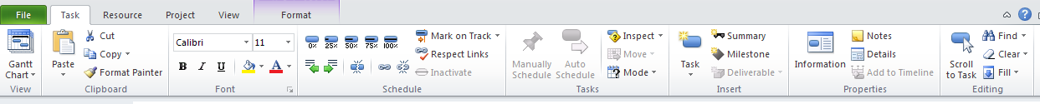

**NOTE:**  Above the Task ribbon name is the Quick Access Toolbar. This toolbar by default contains the buttons for Save, Undo and Redo. By clicking the arrow at the far right side of the Quick Access Toolbar, other buttons may be added. There is also an option to show this toolbar underneath the ribbon bars. Below is a view of the Qucik Access toolbar. Suggestions for helpful buttons to add are: New, Open, Print, and Save As. Customization the Quick Access Toolbar will be discussed in Module 10.



## Resource Tab



The *Resource* ribbon contains buttons which will allow functions that assist with entering, assigning, and leveling resources. Typically, the functions performed directly to resource entries.

Sections contained in the Resource ribbon are:

* View
* Assignments
* Insert
* Properties (Resource)
* Resource leveling

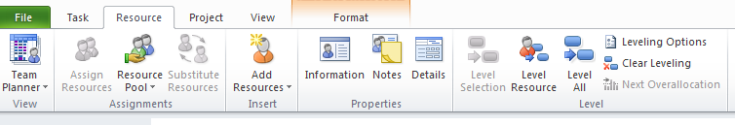

## Project Tab



The *Project* ribbon bar contains buttons which will allow functions that assist with inserting projects into Master Projects, setting project properties, creating custom fields, creating calendars, setting baselines, tracking and reporting.

Sections contained in the Project ribbon are:

* Insert
* Properties (Project)
* Schedule
* Status
* Reports
* Proofing – Spell check

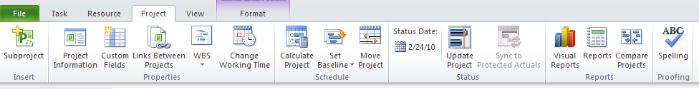

## View Tab



The *View* ribbon contains buttons which provide easy access to views and Gantt Charts. There are buttons that allow highlighting, sorting, filtering and grouping of tasks. Additional buttons will turn the Timeline view on and off, adjust the timescale and create a temporary new window.

Sections contained on the View ribbon are:

* Task Views
* Resource Views
* Data
* Zoom
* Split View
* Windows
* Macros



## Format Tab



The *Format* ribbon contains buttons that provide functions to format custom views and Gantt charts. There are also buttons that will allow for turning on and turning off summary tasks and outline numbers. The view below is the Format ribbon when the Gantt Chart view is revealed.

Sections contained on the Format ribbon are:

* Format
* Columns
* Bar Styles
* Gantt Chart Styles
* Show/Hide
* Drawing

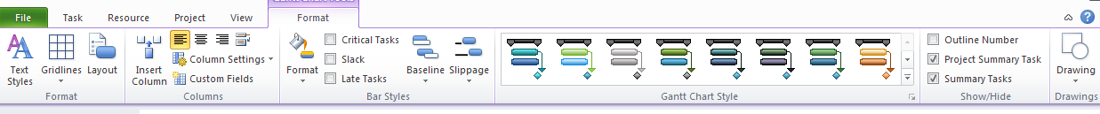

As a comparison, the view below is the Format ribbon when the Resource Sheet is shown.

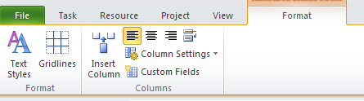

## Backstage Tab



The *Backstage* ribbon is accessed when the File button to the left of the Task ribbon button is pressed. The Backstage contains buttons which provide functions to Save, Open, Close, Print, Customize the ribbon and Project 2010 options.

Sections contained on the Backstage ribbon are:

* Save
* Save As
* Open
* Close
* Info
* Recent
* New
* Print
* Save & Send
* Help
* Options
* Exit

The view below is the Backstage with the Info choice selected. Each selection will reveal different data. By default the last 4 project schedules that were opened will be contained in the left side of the view. The Backstage option choices are highlighted. They will appear in the blue box on the left of the view.

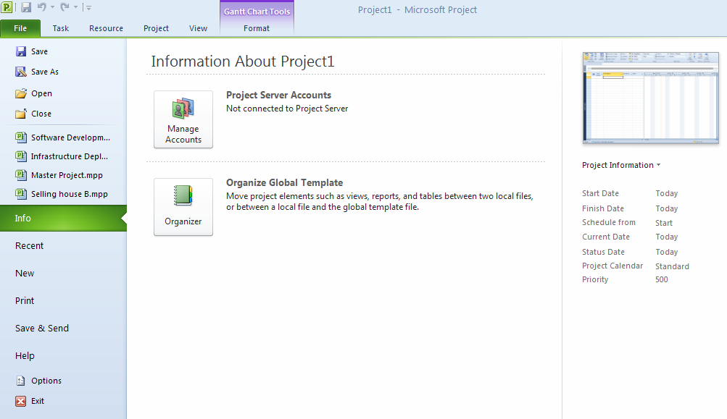

# Lesson 3: Exploring the Project Database (.MPP file)



The most common Project 2010 file format is the .MPP file extension. Project 2010 templates are defined with an .MPT file extension. Templates are stored in the template area in the Backstage. When an .MPT file is opened, the file will open as a copy of the schedule template.

Each file is a database structure containing several parts:

* The Project section contains information that pertains to the entire project schedule
* The Task section contains information pertaining to the tasks or the work of the project – What will be accomplished.
* The Resource section contains information pertaining to the resources of the project. Who will perform the work.
* The Assignment section contains information concerning the details of resource task assignments. When and for how many hours the work is scheduled for.

Rolly – we need a diagram somewhat like this. I know it is not exactly what is going on but it gets the point across.

## Project Data



*Project* is one of the sections of the Project 2010 database. This section will contain information that applies to the entire project schedule.

Data contained in this are:

* Project Start Date or Finish Date
* Project calendar
* Print settings
* Project options
* Project properties

## Task Data



The Task section of the database is defining what work is to be completed. As each task is added to the schedule, over 300 fields of data are added for each task. Some of the fields are calculated by the Project 2010, some are static values and others are user defined fields.

Examples of task field information are:

* Task Name
* Notes
* Schedule planning fields: work, duration and cost
* Scheduling settings: task type, effort-driven setting, task calendar
* Format settings
* Baseline fields
* User defined fields

## Resource Data



The *Resource* data section contains information concerning the resources that will perform the work of the project schedule. The resources are defined as the budget, workers, materials and costs required to complete the project. As each resource is added to the schedule, over 300 fields of data are added to complete the information needed for each resource. Some of the fields are calculated by the Project 2010, some are static values and others are user defined fields. Each work resource will also be assigned a resource calendar.

Examples of resource field information are:

* Resource Name and initials
* Notes
* Resource group
* Schedule planning fields: work (hours) and cost
* Resource calendars
* Baseline fields
* Cost table fields
* User defined fields

## Assignment Data



The *Assignment* section of data contains the information concerning the assignments for each resource. Each assignment is defined as a resource applied to a task to establish the number of hours of work within a specific timeframe. When an assignment is created, data is populated within the assignment section of the database.

Examples of assignment field information are:

* Notes
* Number of hours of work for a task
* Dates the work is scheduled to occur
* Rate table used
* Contouring of work
* Tracking data
* Data may be time-phased.

## Custom Fields



Custom fields or user-defined fields are fields designed to be adapted for individual user requirements. Customizable fields are available in both the Task section and the Resource section of the database. Field types available are:

* Text
* Cost
* Duration
* Start
* Finish
* Outline Code
* Flag
* Number
* Date

To aid custom field development, look-up tables, graphic indicators and formulas are available. When fields are created, you will have the ability to name the field and then keep the custom fields within the project in which they were created. Project 2010 contains a Global template which will allow access to the customized field for all projects on a desktop and the ability to copy these fields between project schedules.

Access to the custom field creation is found in the Project ribbon, 3rd button from the left. User-defined field creation will be discussed in Module 10.

# Lesson 4: Exploring Database Views



Data in Project 2010 is accessed through *Views*. There are several types of views available. Some views are graphic in nature, such as Gantt Charts, graphs and network diagrams. Other views are tabular and resemble Excel spreadsheets. Views are designed to show a unique perspective on the data within the project schedule.

The topics discussed in this lesson are:

* What is a Database view?
* Task Views – views that display the Task section of the database
* Resource Views – views that display the Resource section of the database
* Other views – views that display more than one view

## What is a Database View?



Project 2010 data is accessed through *Views*. Views are broken into categories based on which section of the database they are accessing. The major categories are Task Views and Resource Views. Knowing which view you are in and what data you are looking at will be integral to increasing success in working with Project 2010.

Most views will show one section of the database and other views will show two sections of the database. Using split views, allows the opportunity to view all three sections of the database at the same time. It is very helpful to understand the views and where the data in the view is derived from. This knowledge will be used in future chapters as we discuss other aspects of working with Project 2010.

## Task Views



Task views are accessed through the *Task* ribbon and *Gantt Chart* button located under the Gantt Chart icon. An alternate access point is through the View ribbon. All Gantt Charts contain both the graphic side of the view as well as a table for additional data viewing. All views are available through:

Task ribbon 🡪 button under Gantt Chart icon 🡪 more views 

The following is a summary of the most frequently used Task views:

**Gantt Chart** – the Gantt Chart is a graphic representation of the start and finish dates for a task. In addition to graphic bars, relationship arrows are also displayed. Gantt Charts will have a data table on the left side of the view called the Task Sheet. The default table of data is included called the Entry table which contains fields designed to aid in the planning and scheduling of tasks. The timescale in the view may be adjusted to show different time density timelines. Below is an example of the Gantt Chart view.

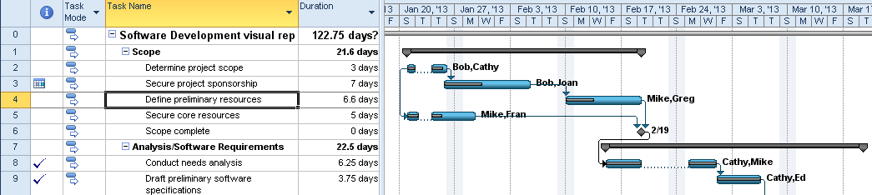

**Tracking Gantt –** this view willgraphically represent of the start and finish dates of a task like the Gantt Chart above but is designed to help during the tracking phase of the project schedule. Percent complete and comparison of baseline versus actual values and future plan are displayed. In the example below, the beige Gantt bars are the baseline and the blue bars is the running schedule.

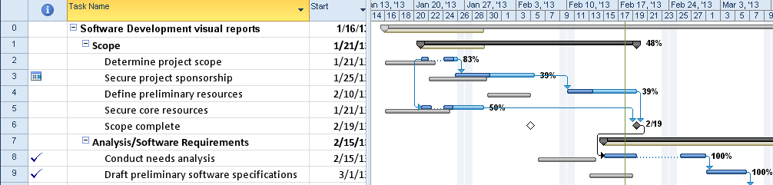

**Network Diagram –** The Network diagram is designed as a precedence diagram.It shows the predecessors and successors of tasks without regard to timeframe. When in the Network Diagram view, clicking on **Format 🡪 Box** styles will explain details about the information represented in the Network Diagram. Double clicking on a task will allows access to task information.

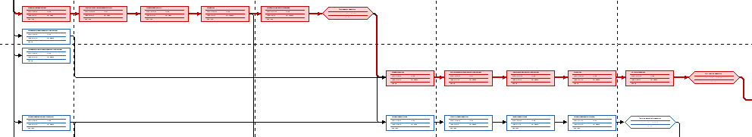

**Calendar view –** The calendar view shows the project schedule on a calendar. Date range is available as well as limited customization. Double click on any task name to see more information regarding the tasks. Some customization of the view is available.

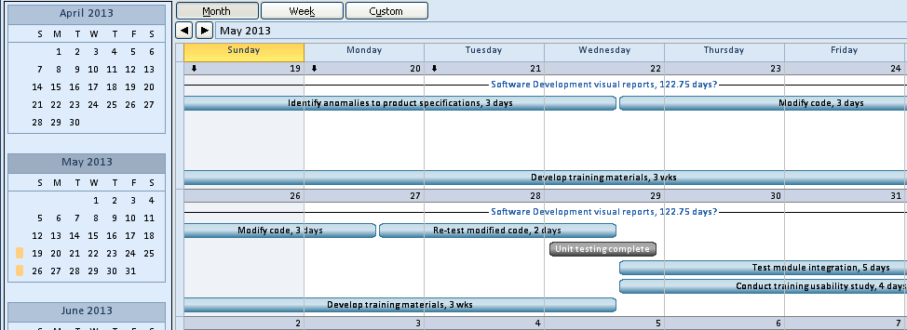

**Task Form –** The task formshows information about individual tasks. Right clicking in the view will allow changing to 8 different views for task data such as predecessor and successor, resource work, and resource schedule. The Task Form is a light version of the Detail Task Form which contains more per task data.

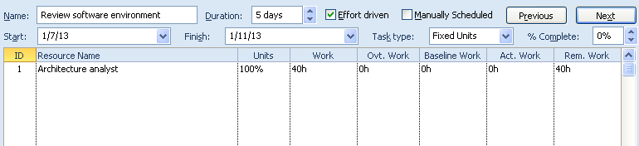

**Task Sheet –** The task sheet view looks like an Excel table. It is a table of data which is a subset of the approximately 300 fields of the task section of the database. Tables are typically 6-10 columns of data, organized by topic. Some of the most used tables are: Entry, Work, Duration, and Tracking. To switch to another table view, right click in the box above the task numbers and select another table from the list. Another access point is:

View 🡪 Tables

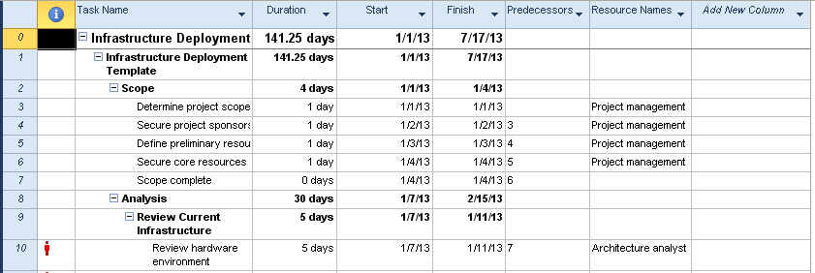

**Timeline View –** The Timeline View is a very flexible and customizable view. Tasks may be selected to appear on the timeline to give high level reporting capability. In addition, the timeline has the ability to highlight the timeframe it is representing. The Timeline View may be turned when needed on the from the **View 🡪** click box to the left of the timeline option. Formatting is available to colorize the view. Comments and milestone markers may also be added. The Timeline view will be discussed in Module 10.



**Task Usage –** The Task Usage view shows tasks and the resources assigned to the task. Data in this view comes from the Task and Assignment data sections of the database. By default, the work field of data is shown on the right but additional fields may be added to customize the report and make it more usable. The example below is showing when a task is scheduled and the cost of the resource working on the task by week.

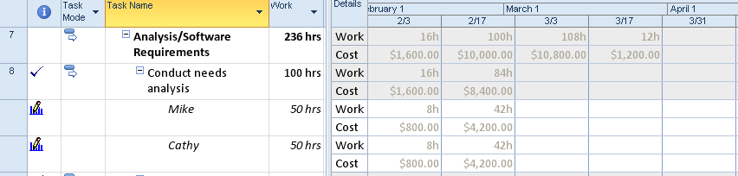

## Resource Views



Resource views are accessed through the *Task* ribbon and *Gantt chart* button under the Gantt Chart icon. They can also be accessed from the Resource ribbon by clicking on the words Team Planner button which is the first button on the on the left side of the ribbon. All views are available through:

Task ribbon 🡪 button under Gantt Chart icon 🡪 More Views 

Resource Sheet – The resource sheet provides the table where resources are added into Project 2010. This table is a subset of the over 300 resource data fields available for resources. The default table is called the Entry table. Other tables are available by right clicking in the in the box above the resource number one and selecting another table. Tables are organized by topic.

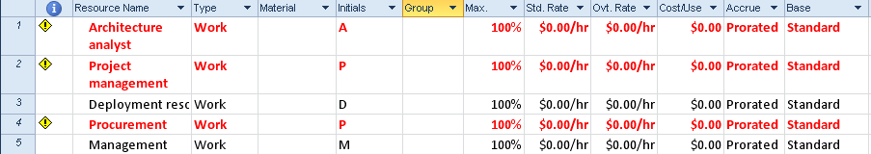

Resource Form - The Resource Form shows information and assignments for individual resources. Right clicking in the view will allow changing to 5 different views which shows the resource assignment data in different ways. The Resource Form is very useful for viewing resource cost, work and schedule information by resource.

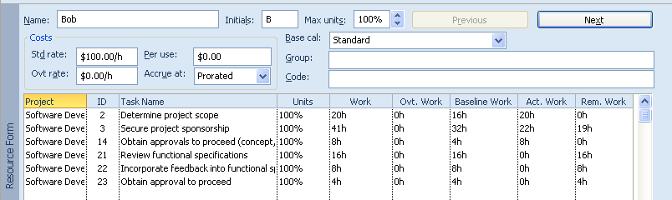

Resource Graph – The Resource Graph will show work and cost values in graphic format for individual resources. The timeline of the graphic display may be altered to show reports at the time density which is most meaningful for the report. Customization is available to change the graphic layout and data included.

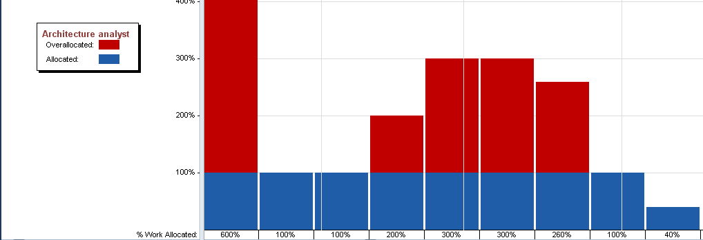

**Team Planner** – the Team Planner view is also known as a swim lane view. It will show the work of the resources in timeline format. It will also allow for moving task assignments between resources and to alternate timeframes. This will be a very helpful view for resource leveling and smoothing out work loads. It will also show tasks without assignments. This view is available for Project 2010 Professional only.



Resource Usage– The Resource Form is a view that shows resources and the tasks assigned to resources. Data in this view comes from the Resource and Assignment data sections of the database. By default the work column is shown on the right side of the screen. In the view below the remaining resource availability has been added.

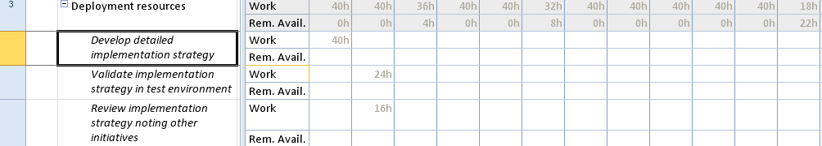

## More Views



Views in the system may be combined into split views to give more information viewed at the same time. The split view can be achieved by clicking the *Details* button on the *Task* ribbon **or** clicking the *Details* button on the *View* ribbon.

* If you are in a task based view and the screen is split, the task form will appear
* If you are in a resource based view and the screen is split, the resource form will appear

Two frequently used split views, noted below, that come with Project 2010 are accessed through:

Task ribbon 🡪 button under Gantt Chart icon 🡪 more views 

**Task Entry View:** The top portion of this view is the Gantt chart and the lower portion is the Task Form. This view is very useful when creating resource assignments.

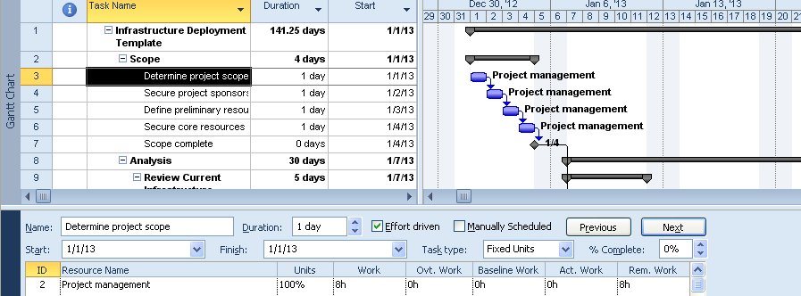

**Resource Allocation View:** The top portion of this view is the Resource Usage View and the lower portion is the Leveling Gantt. This view is very useful when analyzing resource overallocations during the resource leveling function.

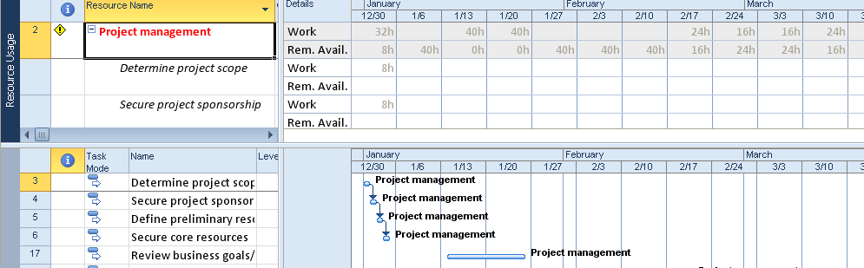

**TIP:**  Be creative, viturally any 2 views may be combined to create a split screen

Any screen may be split by double clicking on the bar below the down arrow in the lower right corner of the view. To remove a split, double click on the split line in the middle of the view.



# Practice: Title of Practice



*The Practice page is where you write detailed instructions for completing work listed as Exercises.*

*Type the Exercise Title and write a brief summary what the student will be doing in the exercise. Then list your ideas what they will be doing.*

*SAMPLE*

*In this practice you will create a Project Server Authentication profile and then configure the local cache settings in Project Professional 2007.*

*Exercise 1: Create Project Server Authentication Profile*

*In this exercise you will create Project Server authentication profile to connect to the Project Web Access site.*

Perform the following exercise on the PS07 virtual machine.

1. *From the* ***Start*** *menu, click* ***All Programs*** *🡪* ***Microsoft Office*** *🡪* ***Microsoft Office Tools*** *and click* ***Microsoft Office Project Server 2007 Accounts****.*
2. *In the* ***Project Server Accounts*** *dialog box, click* ***Add****.*
3. *In the* ***Account Properties*** *dialog box, and complete the following settings and click* ***OK****.*

|  |  |
| --- | --- |
| *Setting* | *Perform the following:* |
|  | |
| *Account Name* | *Type* ***Project Server*** |
| *Project Server URL* | *Type* ***http://epm/pwa*** |
| *When connecting* | *Select* ***Use Windows user account*** |
| *Set as default account* | *Select check box* |

# Summary



Understanding the structure of the data within a Project 2010 schedule will help in understanding what is being shown in the views and tables. In this short overview only the most frequently used views were discussed but there are many more views available.

In this chapter we discussed:

1. Project Management overview
2. Success factors for your project schedule
3. Overview of Project 2010 ribbon or the Fluent Interface
4. Exploring the Project 2010 database (.mpp file)
5. Exploring the Project 2010 views and tables